Phishing Security Awareness Training

Simulation Report

Cybersecurity Audit Project – Employee Vigilance Assessment
Organisation: Cyberttech
Date: 29 June 2025

Prepared By: Aliu B. Sanusi (Snr. Cybersecurity Analyst)

1 · Overview
A phishing simulation was conducted across Sales (30 employees), Marketing (40 employees), and IT (35 employees) to evaluate the effectiveness of prior phishing awareness training.
The exercise simulated a credential-harvesting phishing campaign using a cloned login portal. Results demonstrated a positive trend in employee vigilance:
- Click rates were relatively low (14–20%),
- Credential submissions were minimal (0–1 total),
- Reporting rates increased significantly, especially in Marketing and IT.
These findings show measurable improvement in security culture, with fewer risky behaviors and stronger reporting habits.

2 · Objectives
- Lower link‑click rate among targeted employees.
- Increase phishing incident reports submitted to the security team.
- Reduce credential submission attempts on the phishing landing page.

3 · Compliance Drivers
- ISO 27001 A.7.2.2 (Awareness, Education & Training): This simulation evidences employee awareness testing and supports continuous improvement.
- Internal Risk Register: Addresses phishing risks identified as a top threat vector.

4 · Tooling
- Zphisher – generated the phishing site and captured interaction data.
- Localxpose – optional port‑forwarding for internal access during testing.
- Google Sheets – stored key performance indicators.

5 · Simulation Scenario
A crafted invoice‑reminder email requested payment for WordPress services. The message included a link that directed recipients to a clone login page hosted with Zphisher.

5.1 · Phishing Email Template

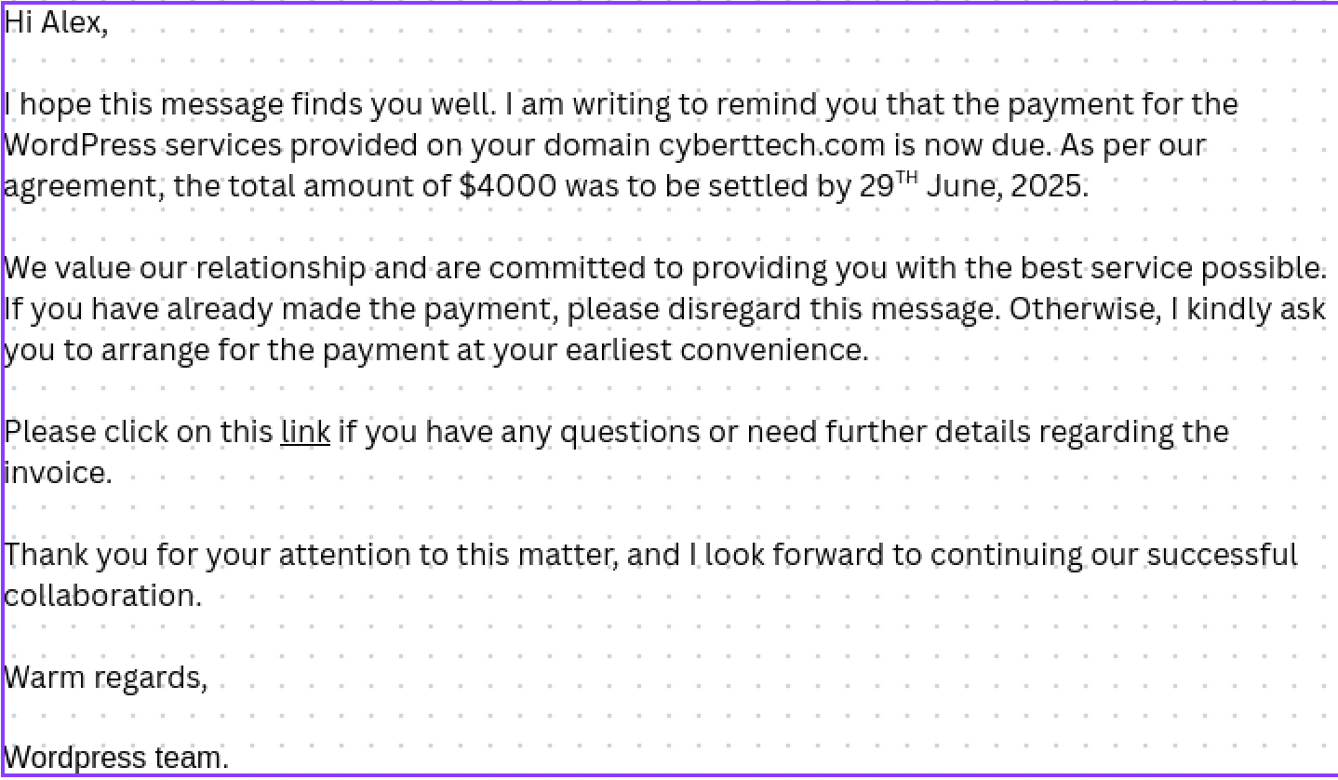

6 · Metrics
Before training, phishing simulations showed higher click rates, higher credential submissions, and lower reporting.
Department | Employees Tested | Link Clicks | Credential Submissions | Phishing Reports | Click Rate (%) | Submission Rate (%) | Report Rate (%)
Sales | 30 | 10 | 4 | 3 | 33.3% | 13.3% | 10.0%
Marketing | 40 | 15 | 6 | 5 | 37.5% | 15.0% | 12.5%
IT | 35 | 12 | 3 | 4 | 34.3% | 8.6% | 11.4%

Post-training results shows clear positive improvement:
- Click rate dropped from ~35% → ~15–20%.
- Credential submissions dropped from 13% → almost 0%.
- Report rate increased from ~10–12% → 33–47%.

Department | Employees Tested | Link Clicks | Credential Submissions | Phishing Reports | Click Rate (%) | Submission Rate (%) | Report Rate (%)
Sales | 30 | 5 | 1 | 10 | 16.7% | 3.3% | 33.3%
Marketing | 40 | 8 | 0 | 19 | 20.0% | 0.0% | 47.5%
IT | 35 | 5 | 0 | 14 | 14.3% | 0.0% | 40.0%

7 · Analysis
- Sales: Moderate click rate (16.7%) with 1 credential submitted. Improvement is needed in recognizing malicious login requests.
- Marketing: Higher click rate (20%), but zero credentials submitted — showing employees are stopping before full compromise. Reporting rate (47.5%) was the highest across all teams.
- IT: Lowest click rate (14.3%) with strong reporting (40%), suggesting high awareness levels.

8 · Recommendations
- Targeted Follow-Up Training for Sales team on credential phishing indicators.
- Reinforcement Sessions for all employees highlighting the importance of reporting suspected emails.
- Quarterly Simulations to measure sustained improvement and meet ISO 27001 awareness control.
- Gamified Awareness Programs (leaderboards, recognition for reporting) to encourage higher vigilance.

9 · Conclusion
This phishing simulation confirms that awareness training is having a measurable impact. The reduction in credential submissions and increase in reporting rates provide strong evidence of a maturing security culture. With continued reinforcement, the organization can further reduce phishing risk exposure and maintain compliance with ISO 27001.

